

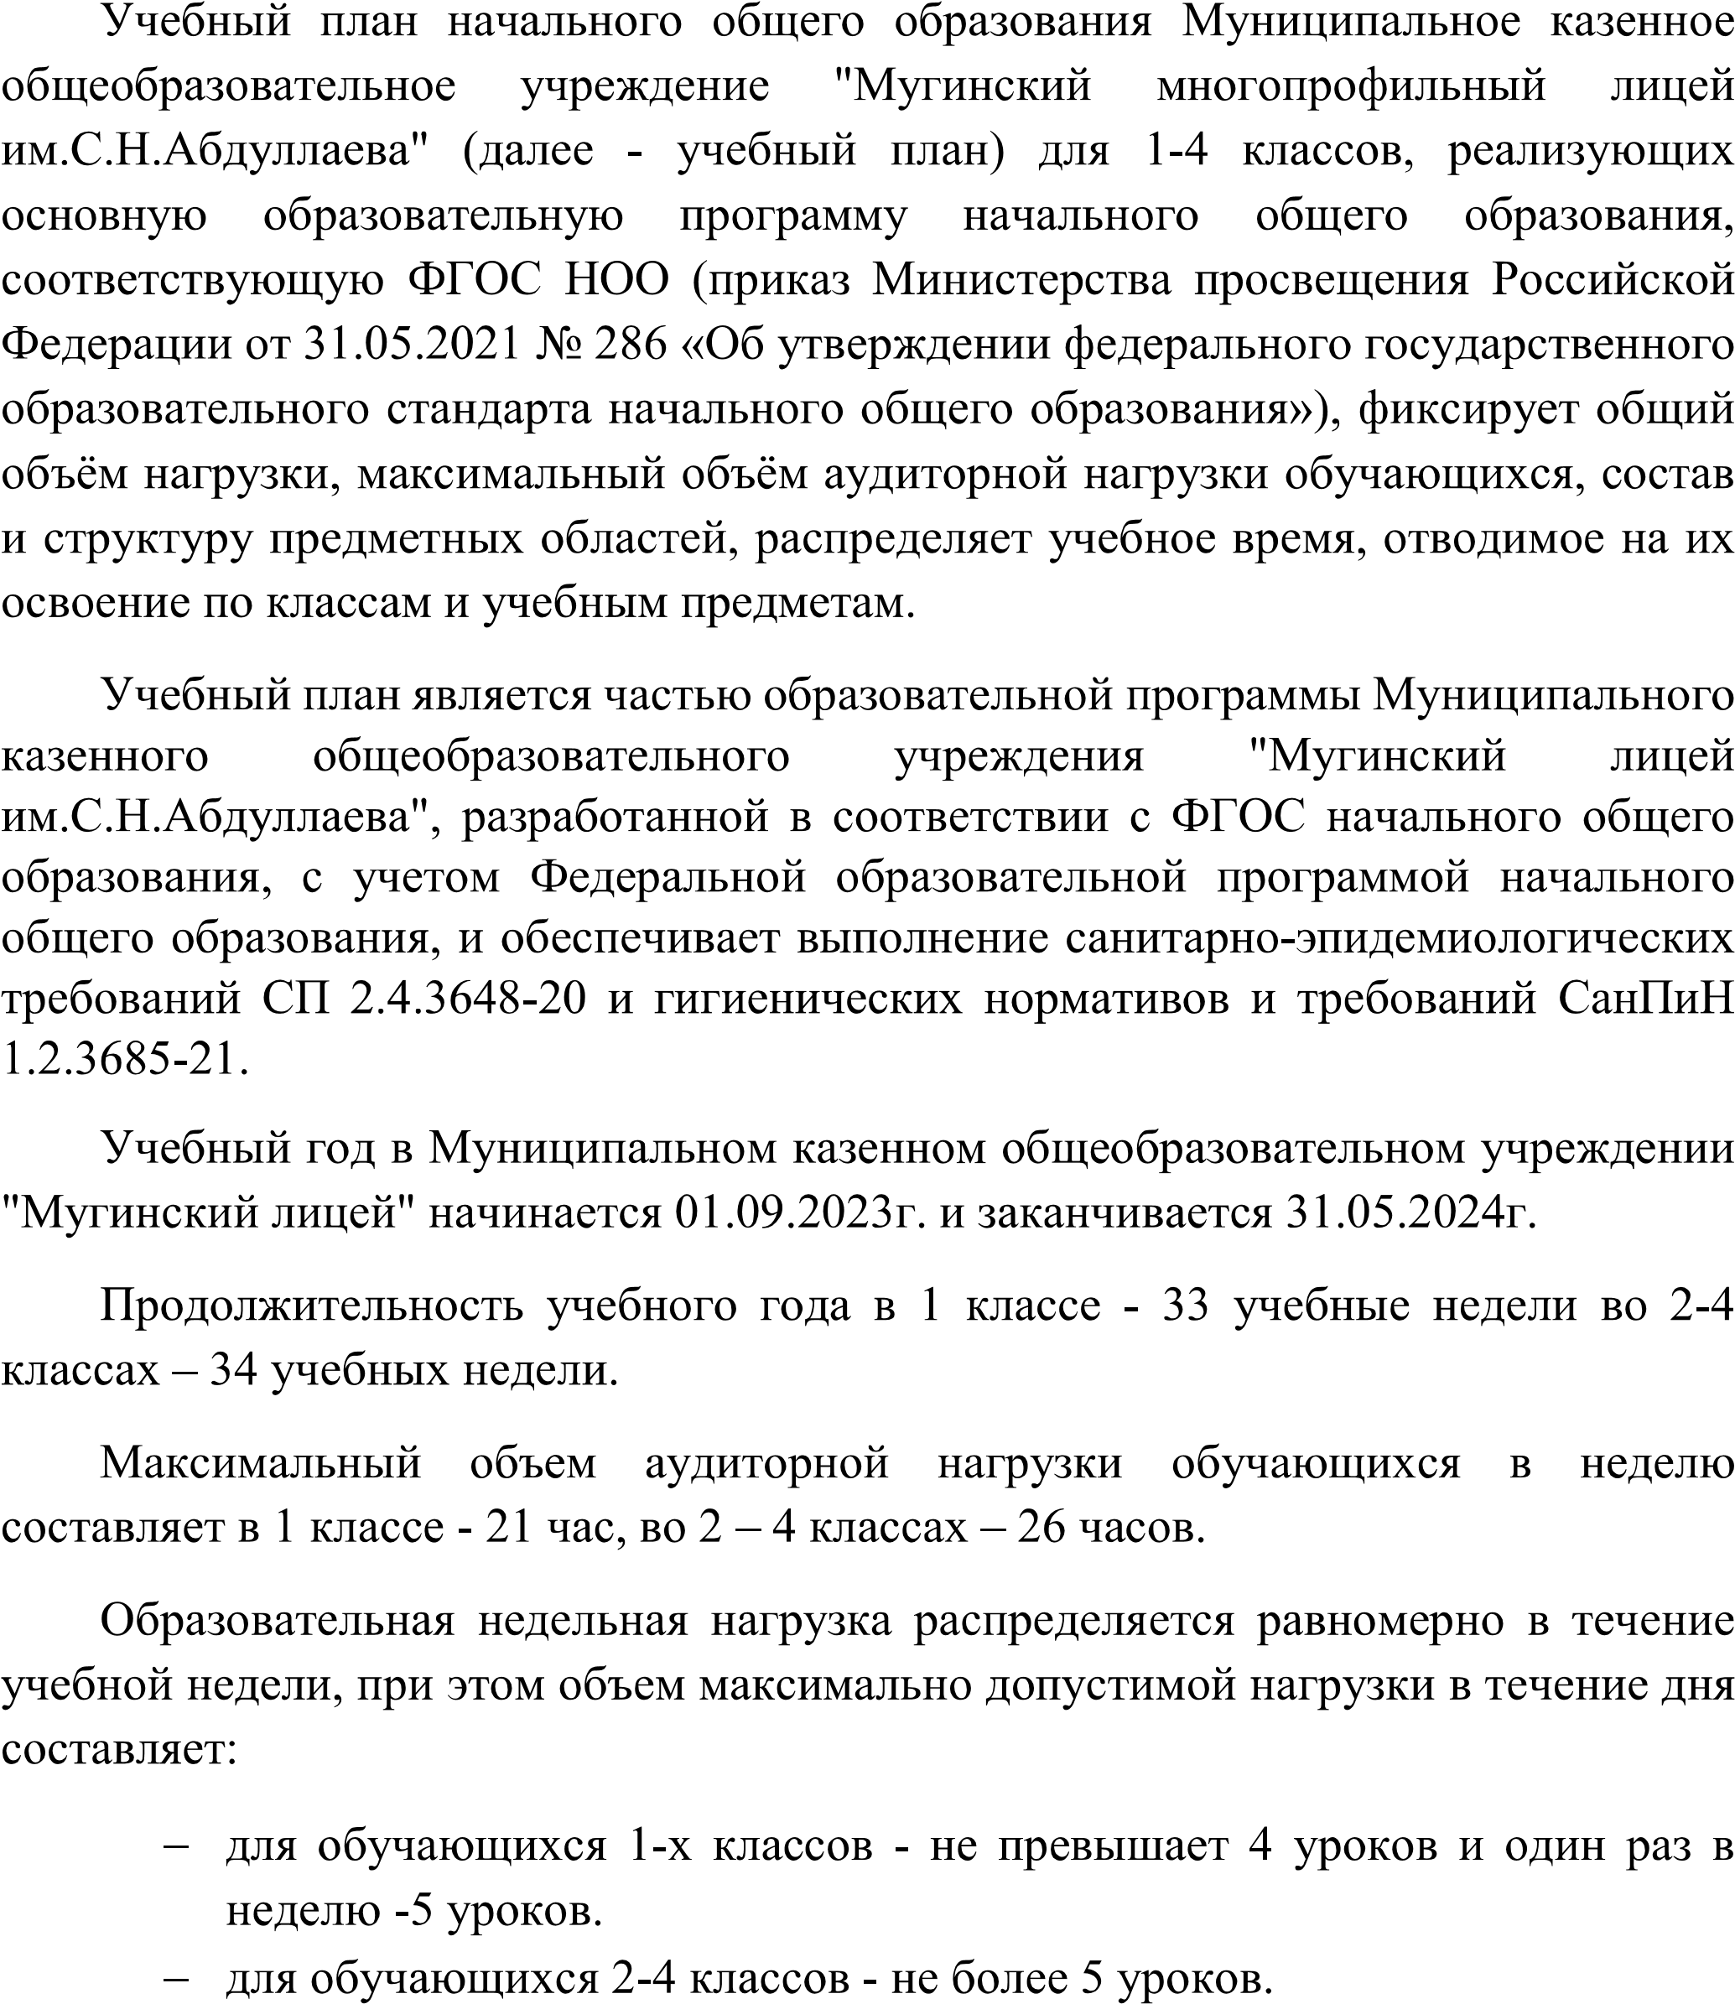

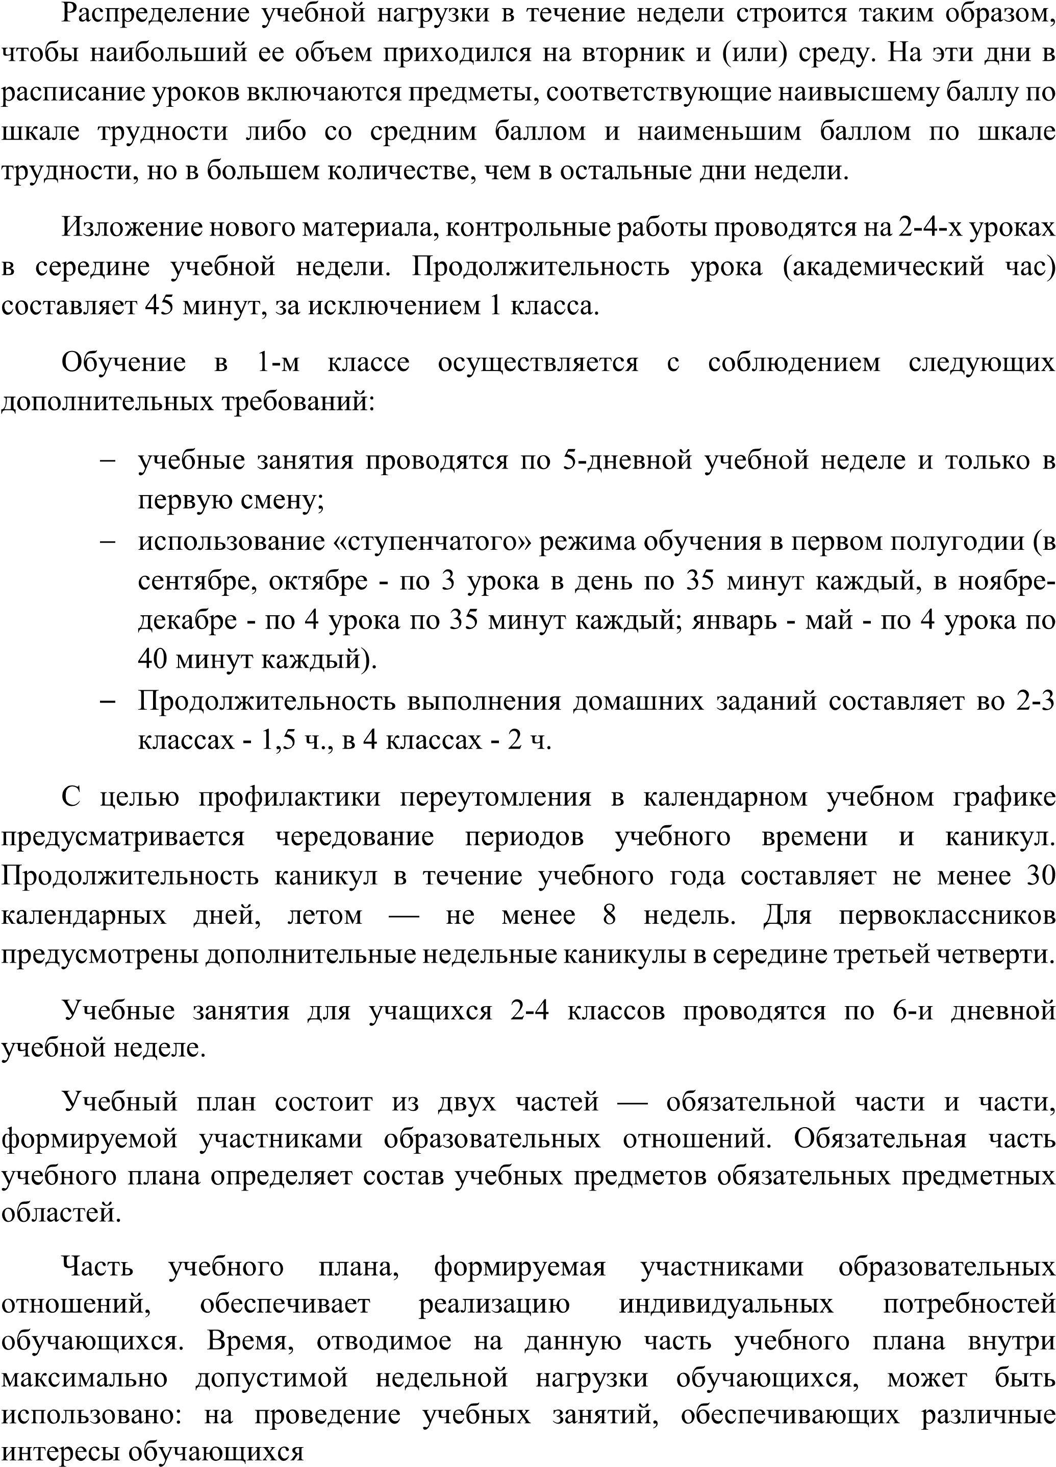

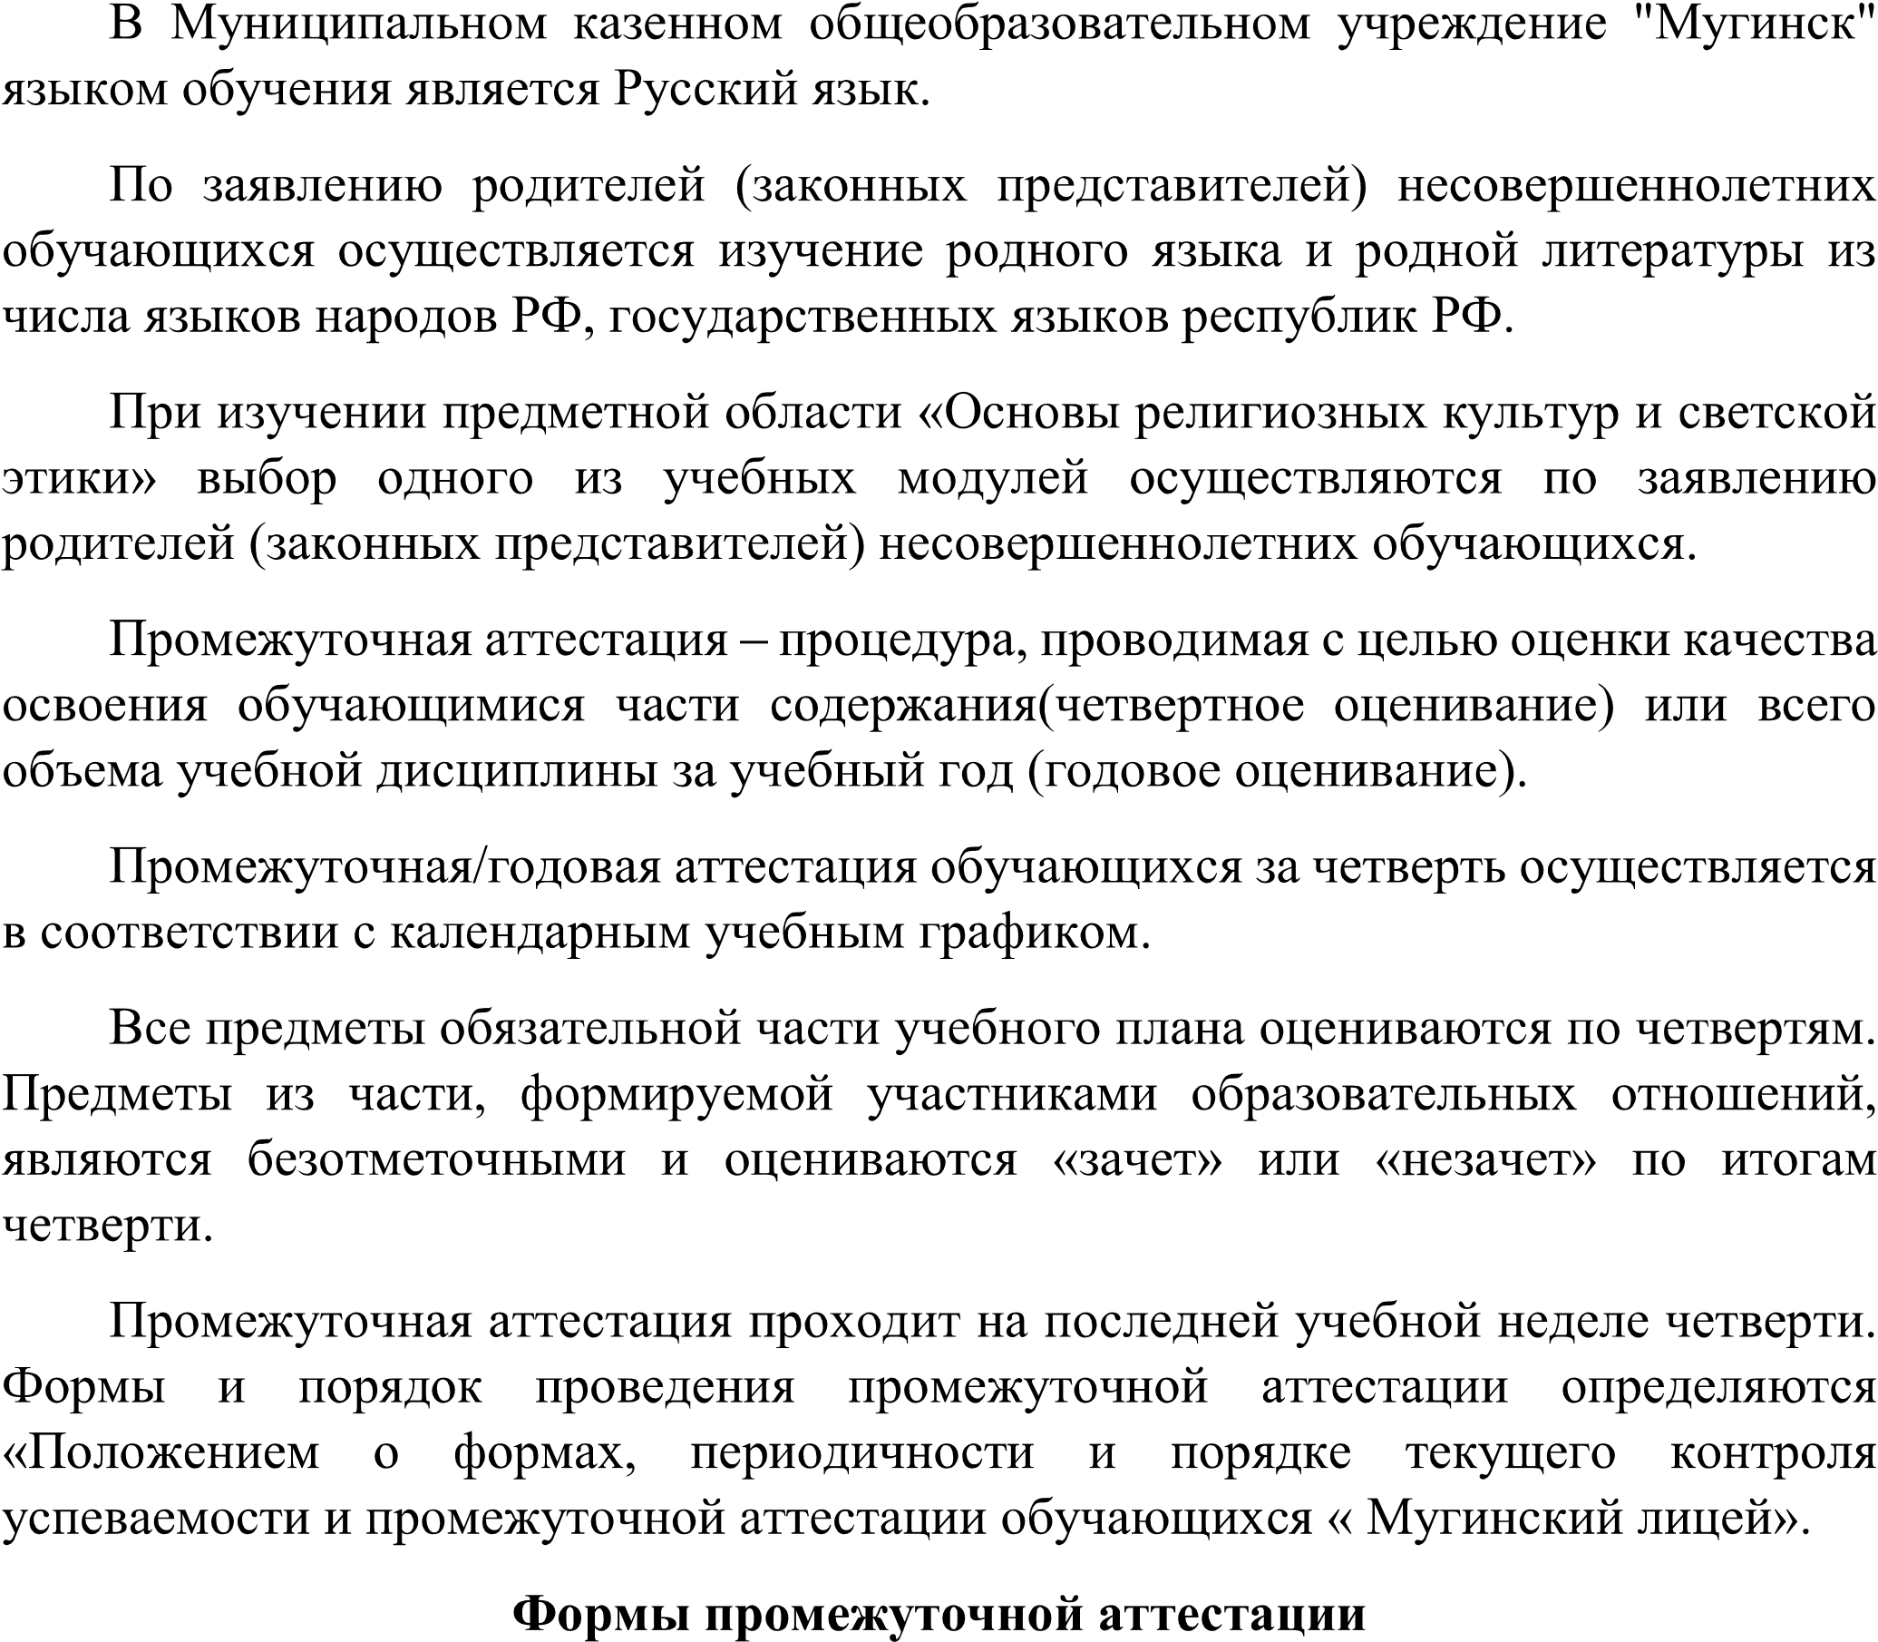

|  |  |  |
| --- | --- | --- |
|  |  |  |
|  |  |  |
|  |  |  |
|  |  |  |
|  |  |  |

|  |  |  |
| --- | --- | --- |
|  |  |  |
|  |  |  |
|  |  |  |
|  |  |  |
|  |  |  |
|  |  |  |

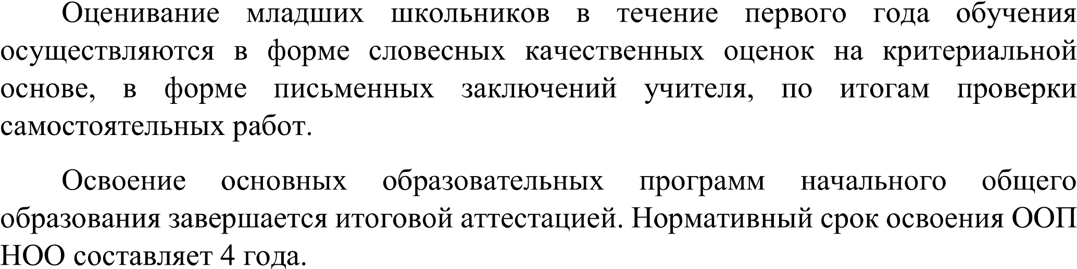

|  |  |  |  |  |  |
| --- | --- | --- | --- | --- | --- |
|  |  |  | | | |
|  |  |  |  |
|  | | | | | |
|  |  |  |  |  |  |
|  |  |  |  |  |
|  |  |  |  |  |  |
|  |  |  |  |  |
|  |  |  |  |  |  |
|  |  |  |  |  |  |
|  |  |  |  |  |  |
|  |  |  |  |  |  |
|  |  |  |  |  |  |

|  |  |  |  |  |  |
| --- | --- | --- | --- | --- | --- |
|  |  |  |  |  |  |
|  |  |  |  |  |  |
|  | |  |  |  |  |
|  | |  |  |  |  |
|  | |  |  |  |  |
|  | |  |  |  |  |
|  | |  |  |  |  |



|  |  |  |  |  |
| --- | --- | --- | --- | --- |
|  |  | | | |
|  |  |  |  |
|  |  |  |  |  |
|  |  |  |  |  |
|  |  |  |  |  |
|  |  |  |  |  |
|  |  |  |  |  |

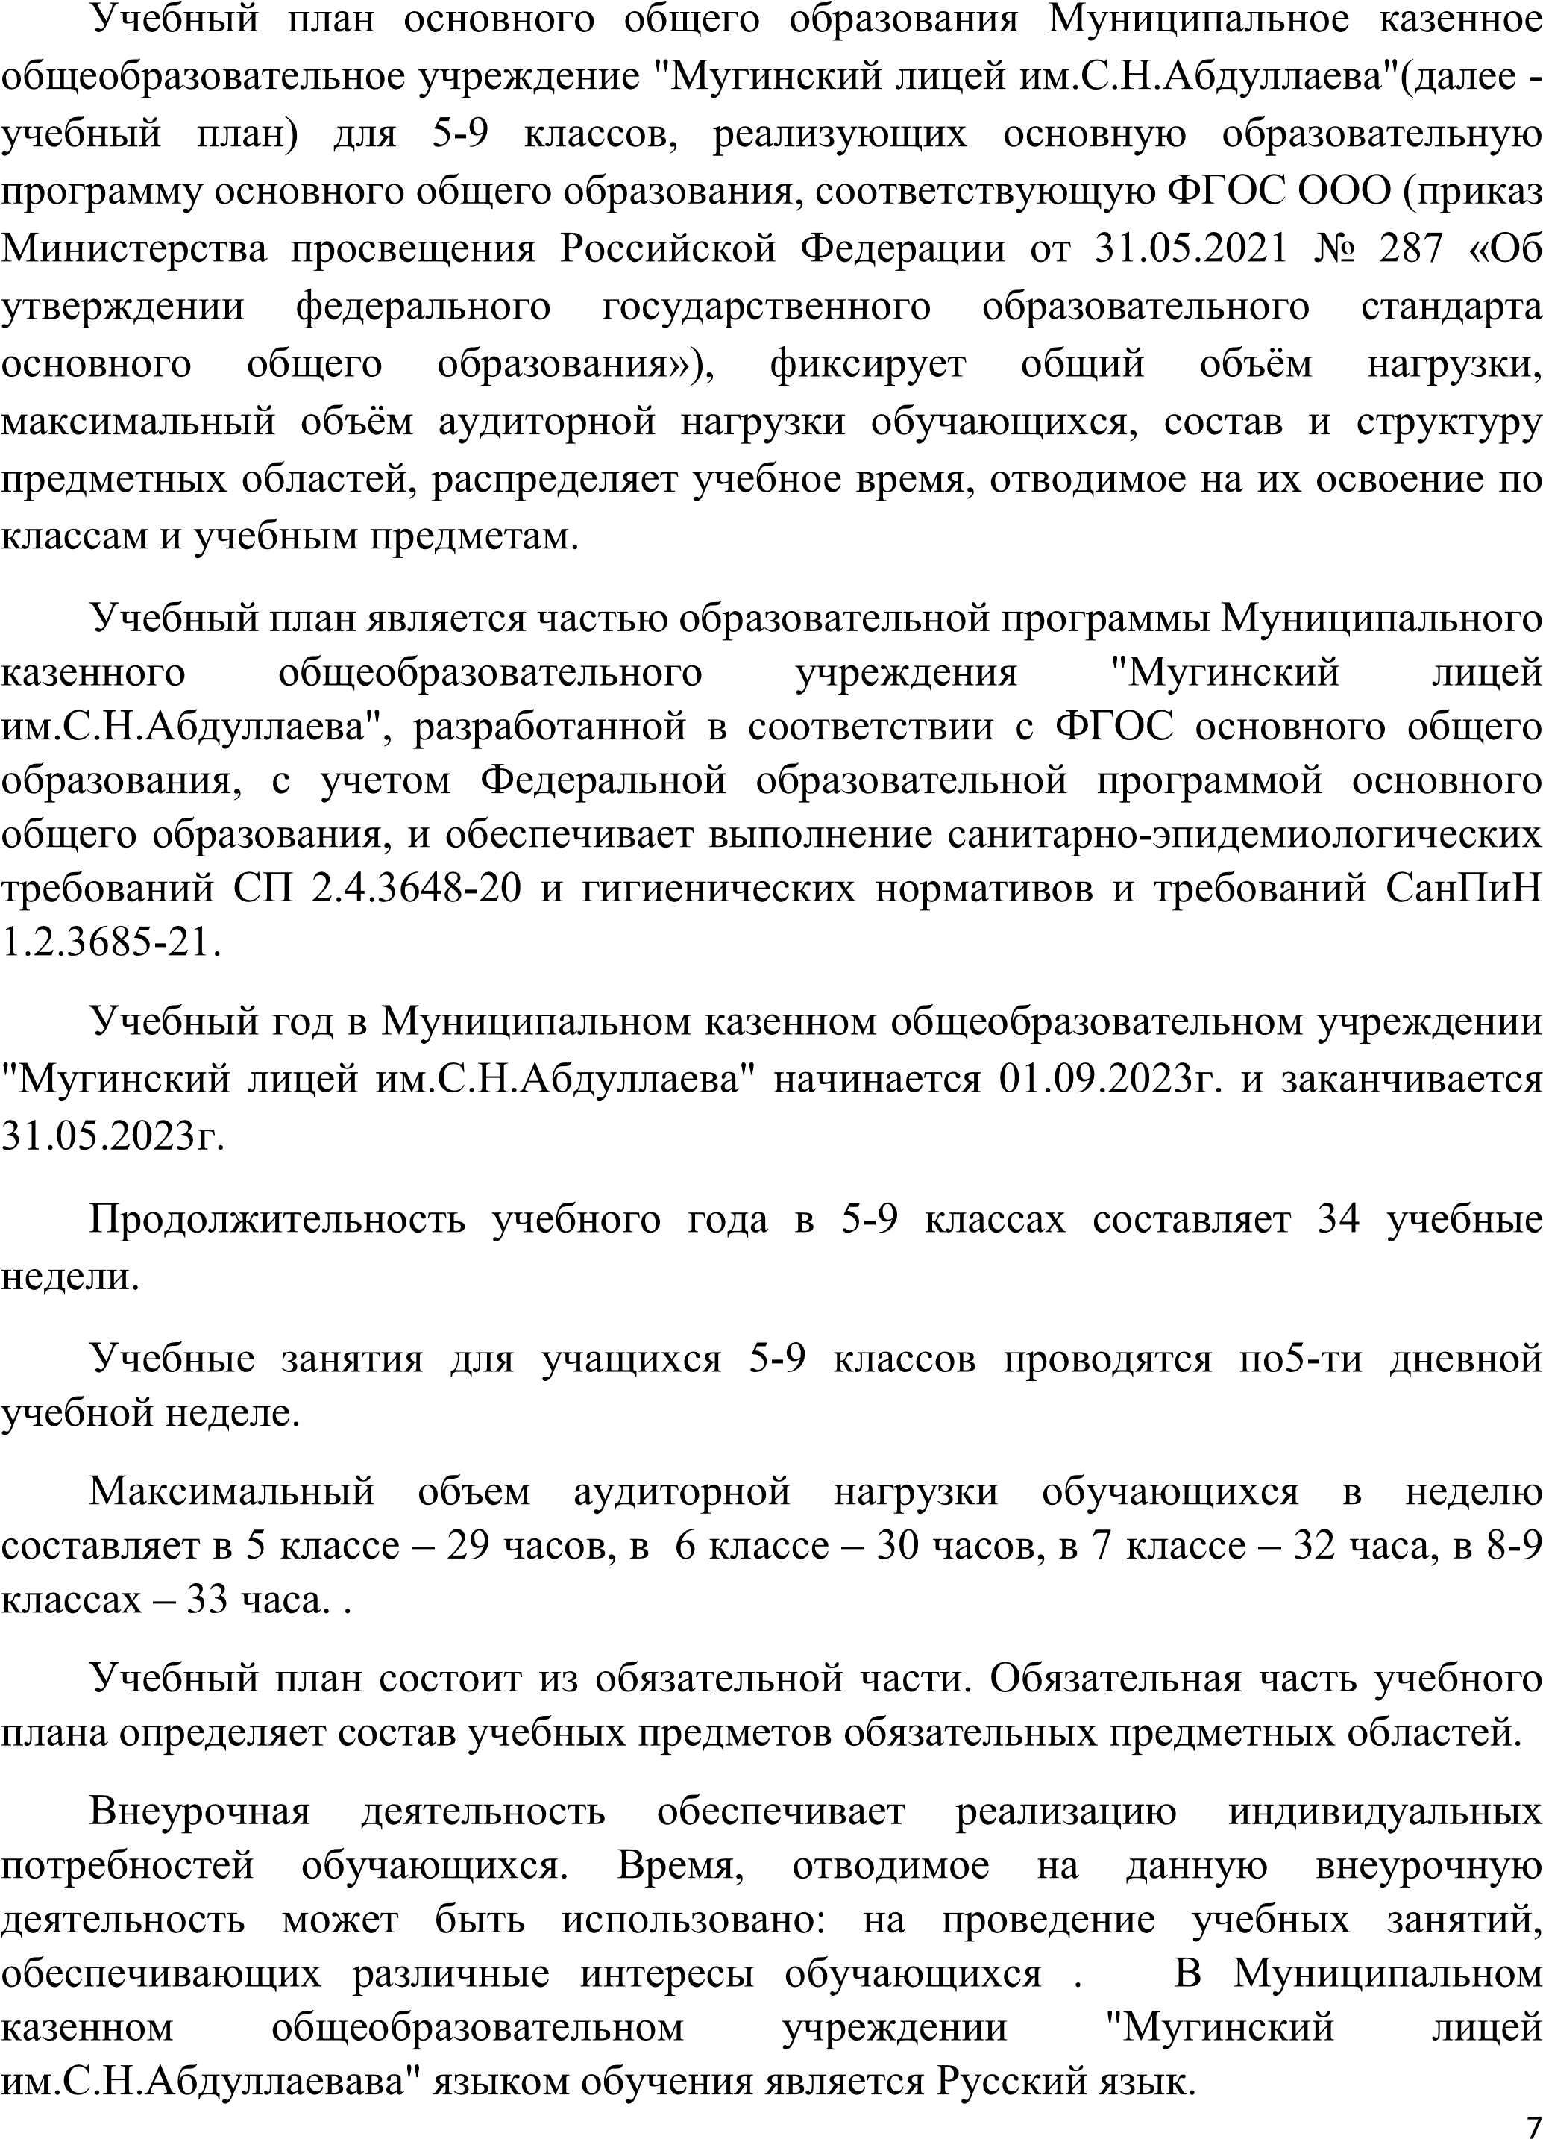

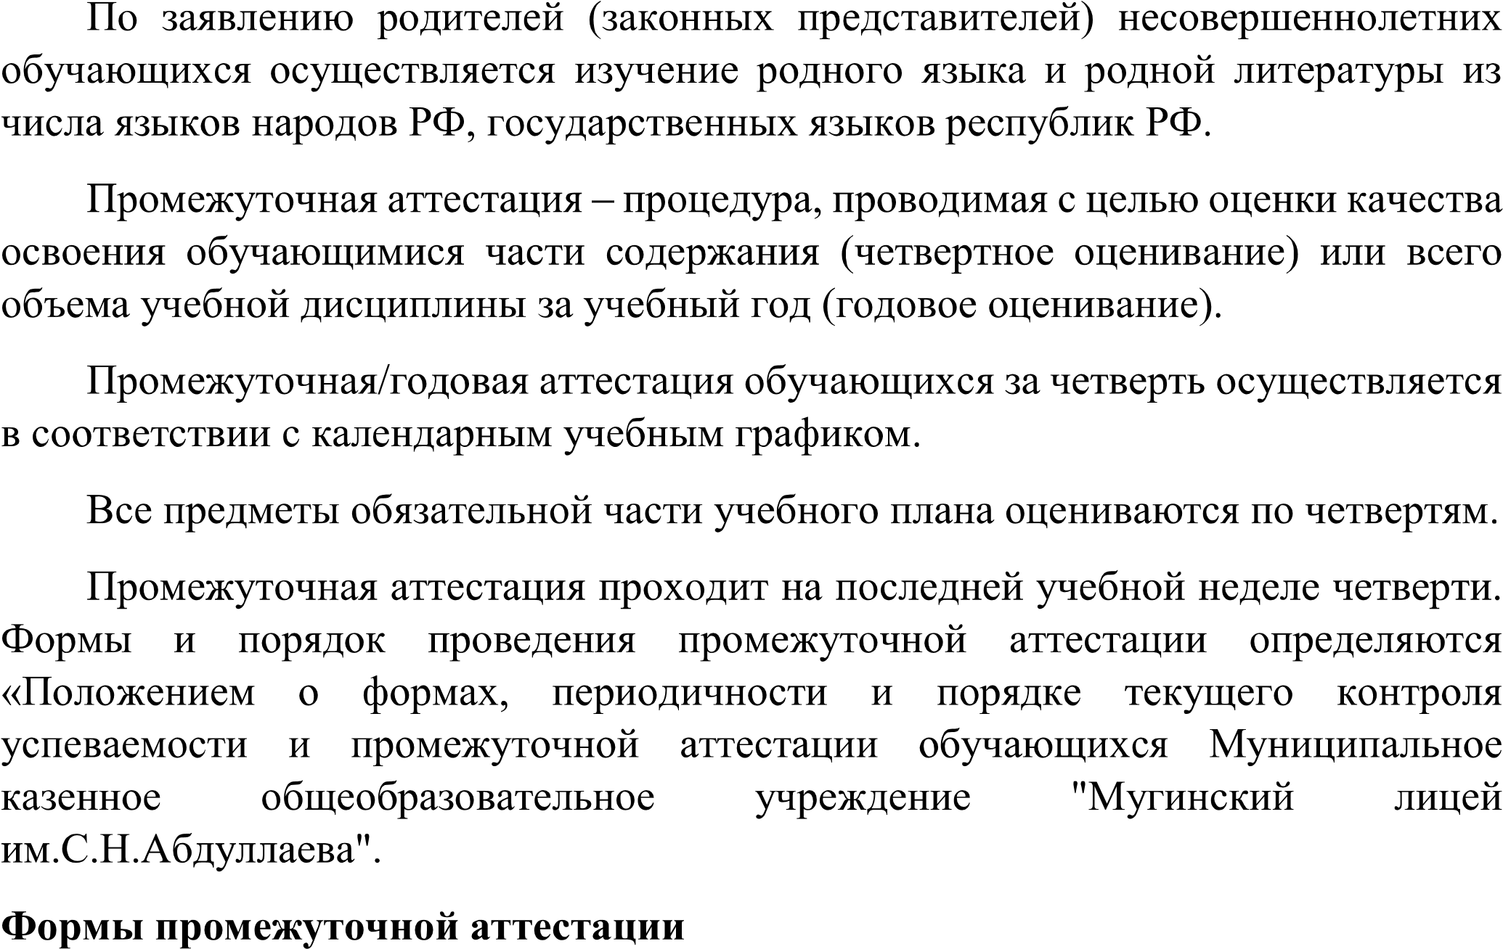

|  |  |  |
| --- | --- | --- |
|  |  |  |
|  |  |  |
|  |  |  |
|  |  |  |
|  |  |  |
|  |  |  |
|  |  |  |
|  |  |  |

|  |  |  |
| --- | --- | --- |
|  |  |  |
|  |  |  |



|  |  |  |  |  |  |  |  |  |
| --- | --- | --- | --- | --- | --- | --- | --- | --- |
|  |  |  | | | | | | |
|  |  |  |  |  |  |  |
|  | | | | |  | |  | |
|  |  |  |  |  |  |  |  |  |
|  |  |  |  |  |  |  |  |
|  |  |  |  |  |  |  |  |  |
|  |  |  |  |  |  |  |  |
|  |  |  |  |  |  |  |  |  |
|  |  |  |  |  |  |  |  |  |
|  |  |  |  |  |  |  |  |
|  |  |  |  |  |  |  |  |
|  |  |  |  |  |  |  |  |
|  |  |  |  |  |  |  |  |
|  |  |  |  |  |  |  |  |  |
|  |  |  |  |  |  |  |  |
|  |  |  |  |  |  |  |  |
|  |  |  |  |  |  |  |  |  |
|  |  |  |  |  |  |  |  |
|  |  |  |  |  |  |  |  |
|  |  |  |  |  |  |  |  |  |
|  |  |  |  |  |  |  |  |
|  |  |  |  |  |  |  |  |  |
|  |  |  |  |  |  |  |  |  |
|  |  |  |  |  |  |  |  |
|  |  |  |  |  |  |  |  |  |
|  | |  |  |  |  |  |  |  |
|  | |  |  |  |  |  |  |  |
|  | |  |  |  |  |  |  |  |
|  | |  |  |  |  |  |  |  |



|  |  |  |  |  |  |  |  |
| --- | --- | --- | --- | --- | --- | --- | --- |
|  |  | | | | | | |
|  |  |  |  |  |  |  |
|  |  |  |  |  |  |  |  |
|  |  |  |  |  |  |  |  |
|  |  |  |  |  |  |  |  |
|  |  |  |  |  |  |  |  |
|  |  |  |  |  |  |  |  |
|  |  |  |  |  |  |  |  |
|  |  |  |  |  |  |  |  |
|  |  |  |  |  |  |  |  |
|  |  |  |  |  |  |  |  |
|  |  |  |  |  |  |  |  |
|  |  |  |  |  |  |  |  |
|  |  |  |  |  |  |  |  |
|  |  |  |  |  |  |  |  |
|  |  |  |  |  |  |  |  |
|  |  |  |  |  |  |  |  |

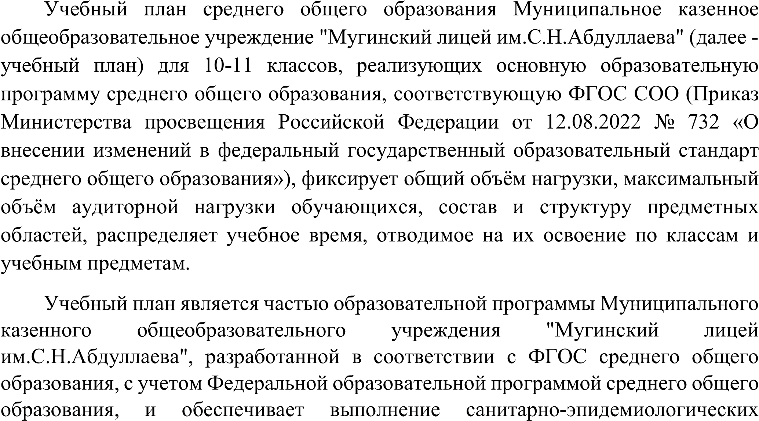

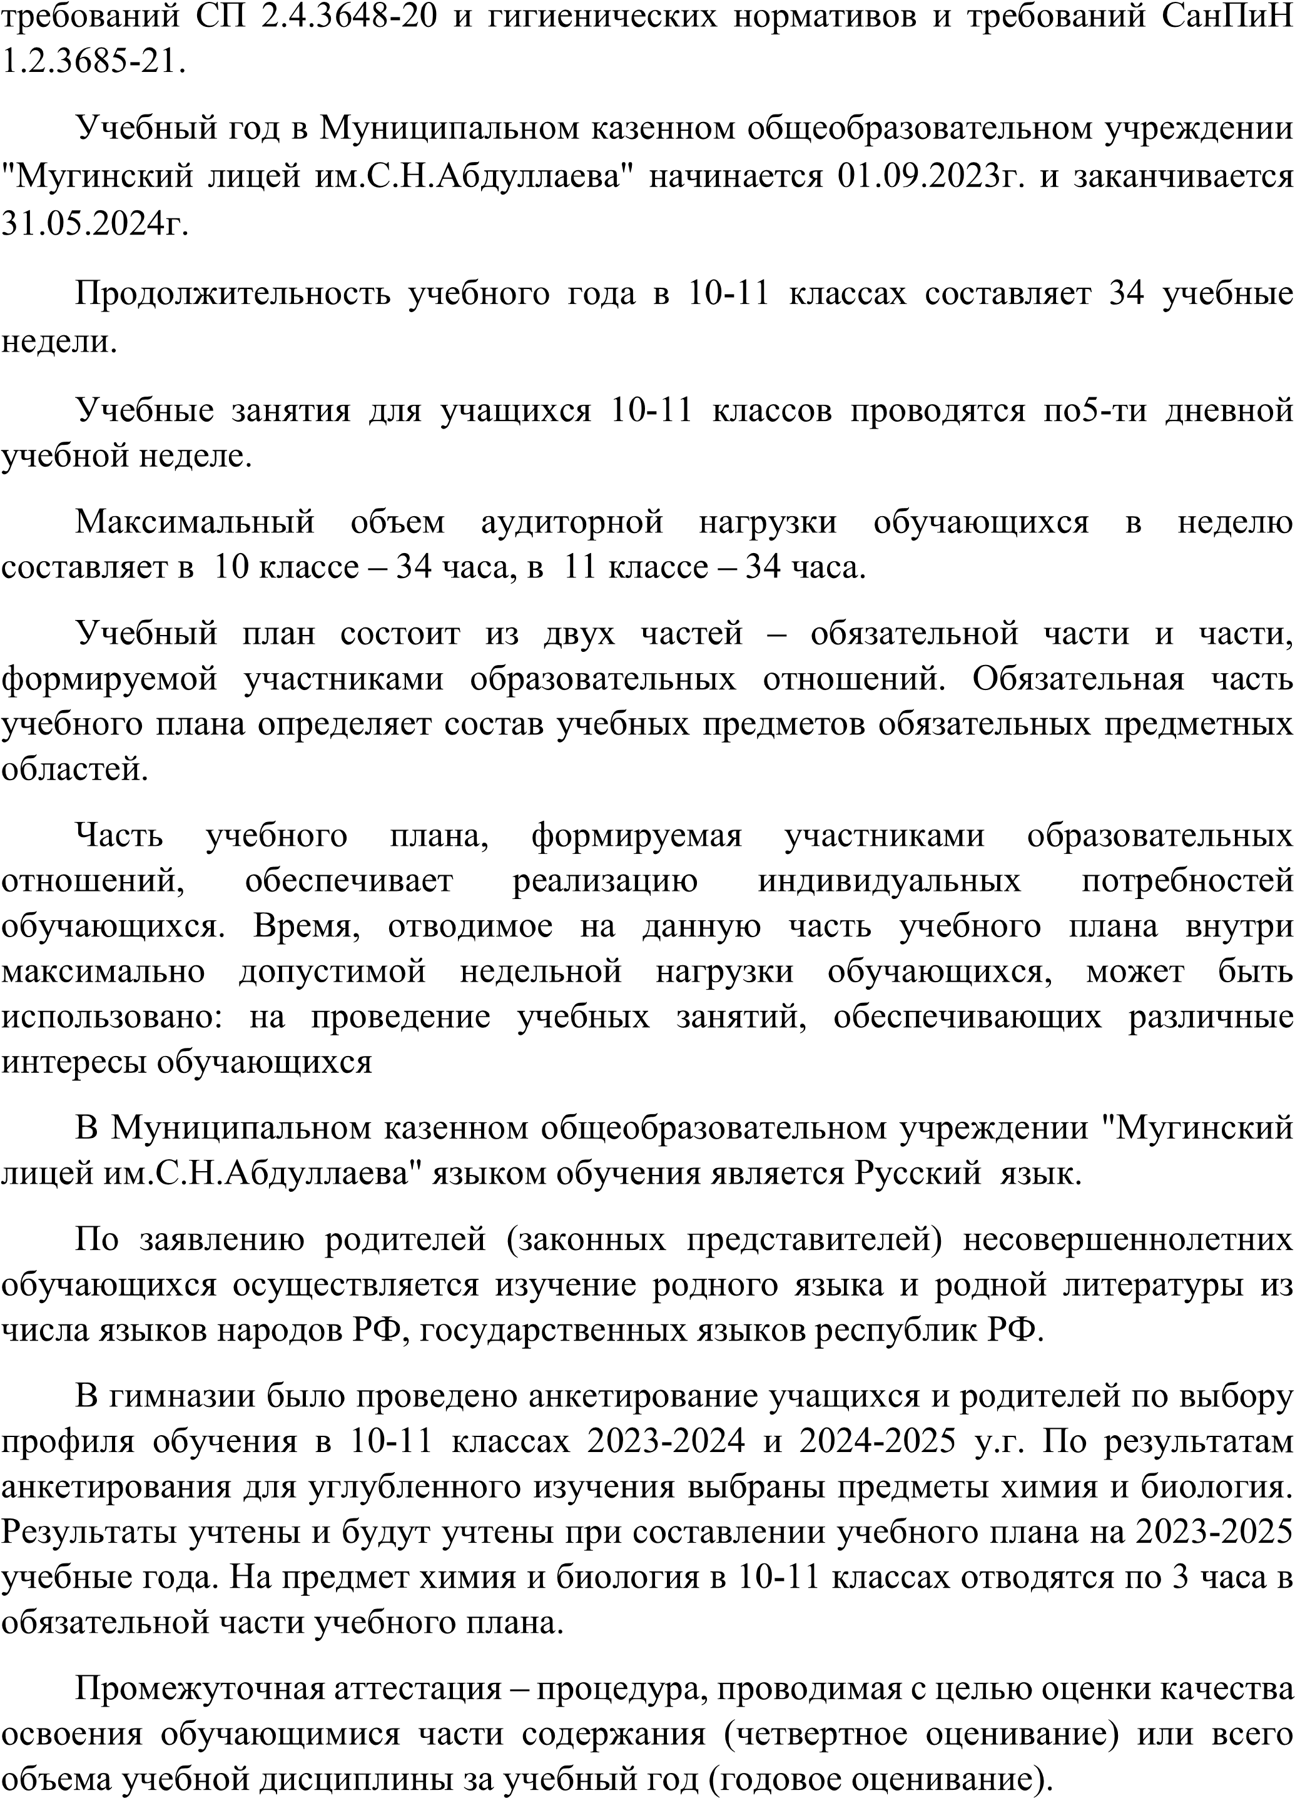

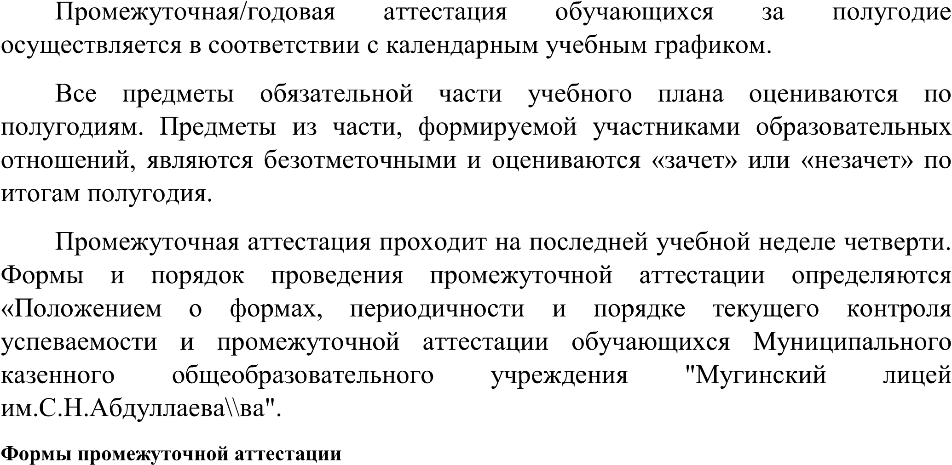

|  |  |  |
| --- | --- | --- |
|  |  |  |
|  |  |  |
|  |  |
|  |  |
|  |  |
|  |  |
|  |  |
|  |  |
|  |  |
|  |  |
|  |  |
|  |  |
|  |  |
|  |  |

|  |  |  |
| --- | --- | --- |
|  |  |  |

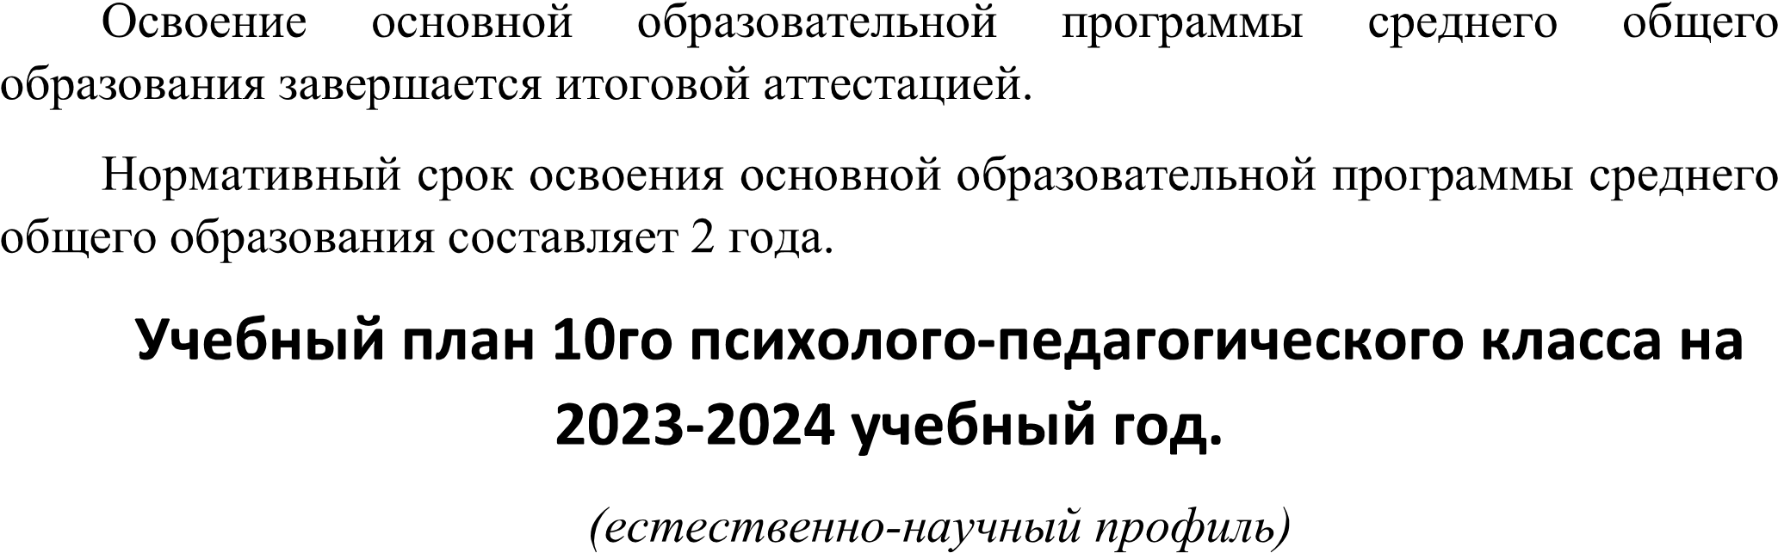

|  |  |  |
| --- | --- | --- |
|  |  |  |
|  |
|  | | |
|  |  |  |
|  |  |
|  |  |  |
|  |  |  |
|  |  |
|  |  |
|  |  |
|  |  |  |
|  |  |
|  |  |
|  |  |  |
|  |  |
|  | У 2 |
|  |  |  |
|  |  |
|  |  |  |
|  | | 31 |
|  | | |
|  |  |  |
|  |  |  |
|  |  |  |
|  | Родной язык (гр) | 0,5 |
|  | Дагест.литература | 0,5 |
|  | | 3 |
|  | |  |
|  | |  |
|  | |  |

|  |  |  |
| --- | --- | --- |
|  |  |  |
|  |
|  | | |
|  |  |  |
|  |  |
|  |  |  |
|  |  |  |
|  |  |
|  |  |
|  |  |
|  |  |  |
|  |  |
|  |  |
|  |  |  |
|  |  |
|  |  |
|  |  |  |
|  |  |
|  |  |  |
|  | |  |
|  | | |
|  |  | 1 |
|  |  |  |
|  |  |  |
|  | |  |
|  | |  |
|  | |  |
|  | |  |



|  |  |  |
| --- | --- | --- |
|  |  | |
|  |  |
|  |  |  |
|  |  |  |
|  |  |  |
| Биология любознательных | 1 |  |
|  |  |  |
|  |  |  |
|  |  |  |
|  |  |  |
|  |  |  |